**6.Photo Restoration:**

**Step 1:**Select your Image that is to be restored .

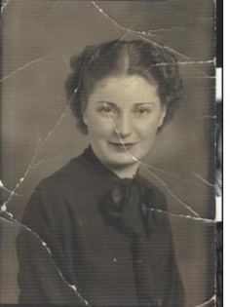

**Step 2:**Take a new layer on this copying the whole image by leaving the original for reference.

**Step 3:**On this layer make a mask for convenience to heal the image.

**Step 4:**After getting your mask ready by using spot heal brush (small size ) firstly remove scars on the photo . Add colour if wanted by using a reference image.

**Step 5:** And then use same tool with bigger size and heal the other parts of image.

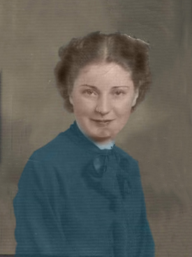

*🡨Final*